IoT Analytics- Project 4: Neural Networks Project
Wen-Han Hu(whu24)
Task 1. Automatic grid search:

Data preparation:

After reading the data from the dataset, we first spilt the data randomly into 2000 training data and 300 testing data. The summary of both dataset as following.

Train Data:
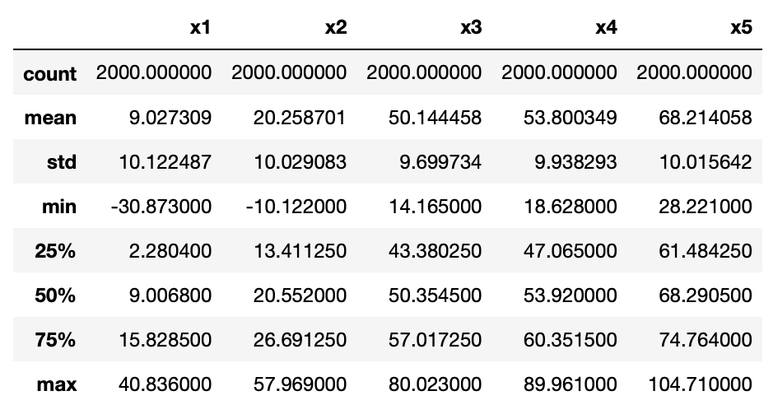
Test Data
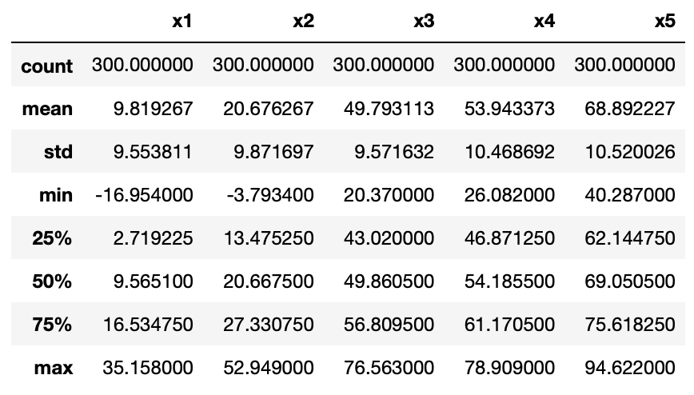
By evaluating the mean, standard deviation above, we can observe that the train and test dataset are very similar distribution which make sure there is not much difference between these two subsets.

Run Automatic grid search:
In order to establish a multilayers neural nets model, we need to decide hyperparameters before we train the NN model. The hyperparameters includes the learning rate γ, the momentum, the regularization parameter 𝜆, and the size of the minibatch. (Reference: textbook section 10.10) If we just simply run everything on automatic grid search, we will have tremendous combination and may spend endless time on waiting the results. Instead of placing everything into the automatic grid search. We use the approach on section 10.10 of textbook which is starting a single hidden layer with 2 or 3 nodes, then we search for the best values of the hyper-parameters, determined the best values, run the previous NN model on a data set, increase the number of nodes, select the hyper-parameters using the previous ones as initial values, and calculate the cost on both train and test data.

Note that, to ease the hyperparameter tuning, we use the recommended minibatch = 32 from textbook.

The first layer automatic grid search results as following.
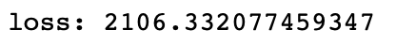
*Note: the alpha here is the same parameter as regularization parameter 𝜆.
*Note: the score is the indicator after 3-fold cross validation. The higher score means the NN modal is better.
*Note: the loss here we use mean squared error as an indicator to evaluate our NN modal performance.

The second layer automatic grid search results as following.
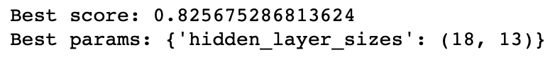
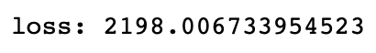
Start from the second layer, we use the previous best values of hyperparameters and tune the best number of nodes on second layer.

*Note: some may argue that the hyperparameter may change due to the hidden layer configuration change. To ensure the those are the best values we checked the hyperparameters with the latest hidden layer configuration to see whether hyperparameters change or not.

The verified results as following.
We use two hidden layers with 18 nodes on first layer and 13 nodes on second layer as we had on prior results. It turns out the hyperparameters have no change.

The third layer automatic grid search results as following.
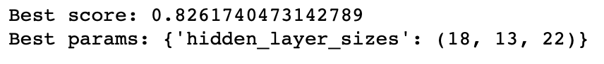
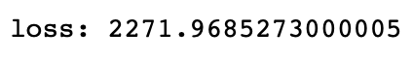
The fourth layer automatic grid search results as following.
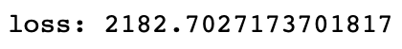
The fifth layer automatic grid search results as following.
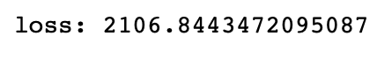
The sixth layer automatic grid search results as following.
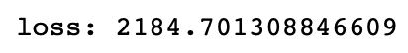

We can, of course, infinitely increase layers in our model, however, the overfitting may occur. Thus, we need to use our test data set to check the number of layers for our model.
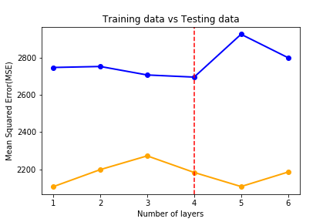
We can observe that our model start overfitting when we added the fifth layer. Thus, we should choose the model with maximum 4 hidden layers.

Conclusion:

